Name________________________
Canon Lenses and intro to camera

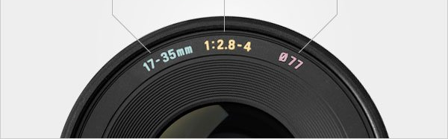

What does Lens Ratio mean?

Tell me about the following lenses?

Standard:

Telephoto:

Zoom:

Fisheye:

Macro:

Looking at the Canon 90d and the T7…

What is the price difference?

What are some other key differences?

Compare the 90d to the Mark VI-

